**POKHARA UNIVERSITY**

APEX COLLEGE

Department of Management

 

MAJOR PROJECT REPORT

ON

**DOCTOR’S APPOINTMENT BOOKING SYSTEM**

BY

Ajai Shakya-(roll no.)

Anish Kayastha-(roll no.)

Ishwor Shrestha-(roll no.)

Manish Chaulagain-(roll no.)

A PROJECT WORK SUBMITTED TO THE DEPARTMENT OF MANAGEMENT IN PARTIAL FULFILLMENT OF THE REQUIREMENT FOR THE BACHELOR OF COMPUTER INFORMATION SYSTEM

**KATHMANDU, NEPAL**

**2023**

**POKHARA UNIVERSITY**

**APEX COLLEGE**

**Department of Management**

The undersigned certify that they have read, and recommended to Pokhara University for acceptance, the project report titled “**DOCTOR’S APPOINTMENT BOOKING SYSTEM**” submitted by [Members,(pu exam roll no.) ] in partial fulfillment of the requirement for the Bachelor of Computer Information System.

[supervisor’s name],

Supervisor

[position, department]

[affiliation]

[internal examiner’s name],

Internal Examiner,

[position, department] ,

[affiliation]

[External exam-

iner’s name],

External Examiner,

[position],

[affiliation]

**DECLARATION**

The project report titled “[PROJECT TITLE]” submitted for the partial fulfillment of the requirement for the degree of Bachelors of Computer Information System to Pokhara University, comprises only original work and due acknowledgement have been made to the materials used in this report.

Ajai Shakya-(roll no.)

Anish Kayastha-(roll no.)

Ishwor Shrestha-(roll no.)

Manish Chaulagain-(roll no.)

[Date of submission]

# ACKNOWLEDGEMENT

ack

# ABSTRACT

abstract

**TABLE OF CONTENTS**

ACKNOWLEDGEMENT i

ABSTRACT ii

LIST OF FIGURES v

LIST OF TABLES vi

LIST OF ABBRIVIATIONS vii

CHAPTER I 1

INTRODUCTION 1

1.1 Background 1

1.2 Scope 1

1.3 Project Description 1

1.4 Objectives 1

CHAPTER II 2

LITERATURE REVIEW 2

CHAPTER III 3

SYSTEM DESIGN AND IMPLEMENTATION 3

3.1 System Design 3

3.1.1 Context Flow Diagram 3

3.1.2 Data Flow Diagram 3

3.1.3 E-R Diagram 3

3.1.4 Use Case Diagram 3

3.2 System Description 4

CHAPTER IV 5

TESTING, DEBUGGING AND RESULTS 5

4.1 Testing 5

4.2 Debugging 5

4.3 Results 5

CHAPTER V 6

SUMMARY 6

5.1 Conclusion 6

5.2 Limitations 6

5.3 Future Enhancement 6

REFERENCES 7

APPENDICES 8

# LIST OF FIGURES

Figure 1 - Figure 111111 3

# LIST OF TABLES

Table 1 - Table 11111111 5

# LIST OF ABBRIVIATIONS

|  |  |  |
| --- | --- | --- |
| AJAX |  | Asynchronous JavaScript and XML |
| API |  | Application Programming Interfaces |
| BCIS |  | Bachelor in Computer Information System |
| CI/CD |  | Continuous Integration and Continuous Deployment |
| CMS |  | Content Management System |
| CSS |  | Cascading Style Sheets |
| HTML |  | Hyper Text Markup Language |
| IT |  | Information Technology |
| JS |  | JavaScript |
| PU |  | Pokhara University |
| SCSS |  | CSS with Superpowers |
| UI |  | User Interface |
| XHTML |  | Extensible Hypertext Markup Language |
| XML |  | Extensible Markup Language |

# CHAPTER I

# INTRODUCTION

## 1.1 Background

## 1.2 Scope

## 1.3 Project Description

## 1.4 Objectives

# CHAPTER II

# LITERATURE REVIEW

# CHAPTER III

# SYSTEM DESIGN AND IMPLEMENTATION

## 3.1 System Design

Vfvfvdfv

### 3.1.1 Context Flow Diagram

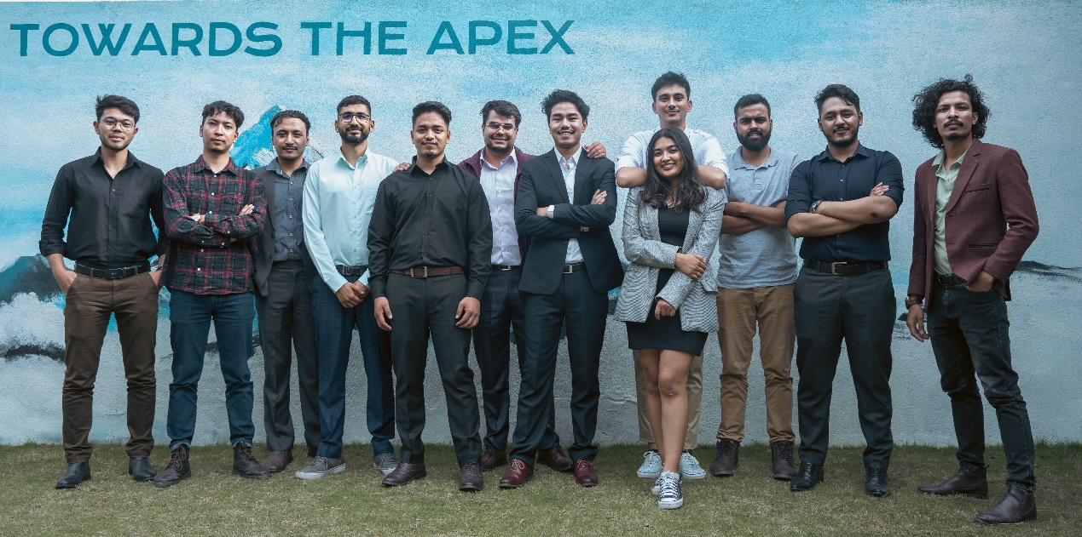

Figure 1 - Figure 111111

### 3.1.2 Data Flow Diagram

### 3.1.3 E-R Diagram

### 3.1.4 Use Case Diagram

Cdsvfvdfbvdfbdbgfnnnnnnnnnnnnnnnnnnnnnnnnnnnnnnnnnnnnnnnnnnnnnnnnnnnnnnnnnnnnnnnnnnnnnnnnnnnnnnnnnn

## 3.2 System Description

descdvdv

# CHAPTER IV

# TESTING, DEBUGGING AND RESULTS

## 4.1 Testing

fbgfb

## 4.2 Debugging

gfbgf

## 4.3 Results

Bfbg

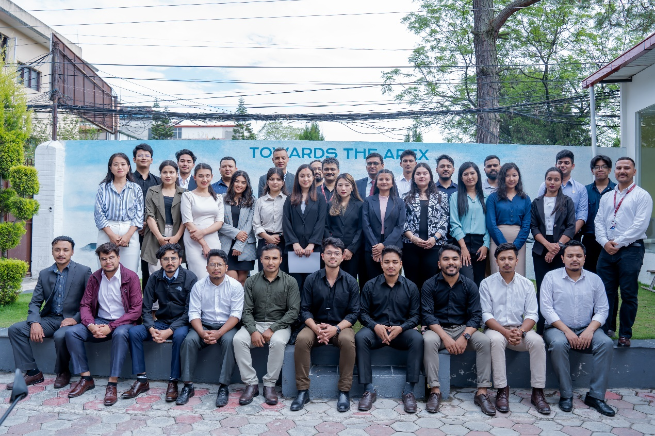

Table 1 - Table 11111111

# CHAPTER V

# SUMMARY

## 5.1 Conclusion

ddfdfdf

## 5.2 Limitations

gdfgdgg

## 5.3 Future Enhancement

gfgfgffg

# REFERENCES

*Introduction*. (n.d.). 2020 ESG. https://corporate.walmart.com/esgreport2020/introduction

# APPENDICES



Gjg